DRAFT – NOT PEER REVIEWED

**Segmentation and shielding as part of an exit strategy from COVID-19 lockdown**

Epigroup, University of Edinburgh and colleagues (26/04/20)

Policy relevance

Current UK and Scottish Government policy is to i) save lives; ii) protect NHS physical capacity (especially ICUs) and iii) protect NHS staff. Segmentation and shielding (S&S) is the only strategy immediately available that allows the prospect of at least partial release of lockdown within weeks while at the same time meeting these goals.

S&S addresses the concern that although the public health burden is highly concentrated in identifiable populations of persons “vulnerable” to COVID-19, the economic, social and psychological costs of lockdown are distributed across the entire population.

A key element of S&S is reducing the exposure and the number of non-essential contacts with vulnerable persons (segmentation),plus, reducing the exposure and the number of their essential contacts (shielding). These include members of the same household, carers, community health workers, care home staff, hospital staff etc. – ‘the shielders’. Any relaxation of lockdown in the general population would not necessarily apply to shielders.

There is a trade-off between the degree of protection afforded to the vulnerable population and the extent to which lockdown can be relaxed for the general population.

COVID-19 can be a serious disease in all age groups and risk groups and as such no level of infection in any subset of the population is acceptable. However, in the non-vulnerable population we propose that COVID-19 could be managed with a more conventional response, centred around appropriate and effective clinical care and proportionate public health measures (including voluntary social distancing practices), without resorting to the severe restrictions on the activities of the entire population imposed by lockdown.

S&S can be integrated with other measures designed to reduce transmission rates (e.g. contact tracing) or reduce the public health burden (e.g. increasing NHS capacity to deliver appropriate and effective care), noting that without S&S neither of those measures is likely to provide an early exit from lockdown. Measures such as self-isolation of cases and quarantining of affected households will remain crucial.

S&S will be most effective with high standards of hygiene and biosecurity between vulnerable and other people. Enablers will include: i) high quality personal protective equipment, especially for shielders; ii) intensive testing of shielders, preferably daily and with a rapid (same day) test for virus and less frequent testing for antibody; iii) appropriate incentives for compliance, especially outside institutions.

However, it may be that existing protections for the vulnerable population could be strengthened immediately.

Summary

We demonstrate that the adoption of a segmenting and shielding (S&S) strategy could increase the scope to partially exit COVID-19 lockdown over a time period of weeks.

We illustrate the S&S strategy using a simple mathematical model that considers a gradual ramping up of protection for the vulnerable population and a gradual ramping down of restrictions on the non-vulnerable population over a period of 12 weeks.

Transmission rates within the general population and between the general and vulnerable populations are the most important determinants of success. These could be kept low by maintaining strict social distancing measures in the vulnerable group.

Less relaxation of restrictions may be possible for shielders than for the general population.

S&S is far less likely to succeed if the designated vulnerable segment is too small (e.g. 2% vs. 20%).

Results are influenced especially by the contact matrix between segments and the relationships between social distancing measures and transmission rates. These relationships are difficult to quantify precisely so close monitoring of the epidemic curve would be essential during and after the exit from lockdown.

Introduction

As of 25/04/2020, 2,719,897 confirmed COVID-19 cases and 187,705 COVID-19 related deaths had been reported globally [WHO, 2020]. Countries around the world have imposed severe social distancing measures – ‘lockdown’ – on their entire population to reduce the rate of spread of infection [OECD, 2020]. These measures cause huge (though not fully quantified) societal, psychological and economic harm [OECD, 2020] so there is an urgent need to find ways of exiting lockdown safely.

Here, we consider one option for facilitating exit from lockdown: segmenting and shielding (S&S). Segmenting is dividing the population into groups that are relatively homogeneous in healthcare characteristics or needs [Low et al, 2020]. Shielding is a way to protect people who are extremely vulnerable to severe COVID-19 outcomes by minimising all interaction between them and other people [British Lung Foundation, 2020].

Key risk factors for vulnerability to COVID-19 are defined by the World Health Organisation (WHO) as: older people (that is people over 60 years old); and those with underlying medical conditions (such as cardiovascular disease, diabetes, chronic respiratory disease, and cancer) [WHO, 2020]. The UK has identified vulnerable persons and issued specific advice for them to shield from possible COVID-19 infection (Table S1).

There have been numerous mathematical modelling studies of the actual and predicted impact of social distancing measures on COVID-19 epidemics [e.g. Leung et al, 2020; Chatterjee et al, 2020; Bayham et al, 2020; Tuite et al, 2020; Kim et al, 2020; Prem et al, 2020; Block et al, 2020]. Very few have explicitly considered shielding [McKeigue and Colhoun, 2020; Neufeld et al, 2020; Weitz et al., 2020] and, despite its inclusion as part of national and international strategy for responding to COVID-19, shielding is not included by any of the mathematical models being used to inform policy in the UK, nor (to the best of our knowledge) any other country. One modelling study in the UK concluded that social distancing of those over 70 years old (including a 75% reduction of contacts outside home and workplace) would contribute to reducing the burden on the National Health Service (NHS), though lockdown would still be needed to keep burden within NHS capacity [Ferguson et al, 2020].

We therefore constructed a mathematical model designed to explore the complex trade-offs between increasing protection for some population segments (shielding) and relaxing restrictions on other segments (lifting lockdown). Key features of our approach include: i) explicit consideration of the contact structure between three population segments: vulnerable (v); shielders (s); and the rest of the population (g) (general population) and ii) rapidly decaying post-infection immunity.

We use the model to explore the potential of S&S to meet specific policy objectives for the UK, namely: i) to save lives; ii) to prevent NHS capacity being overwhelmed; and iii) to protect NHS staff. Policy constraints that could also impact on the range of strategies that could be used. We consider three, increasingly restrictive, constraints:

1. future levels of infection in the vulnerable population to be kept at levels no higher than at the start of lockdown;
2. future levels of infection in the entire population to be kept at levels smaller or, at maximum, the same as they are currently;
3. Numbers of cases/deaths not to increase.

Constraints (1) and (2) would allow levels of infection to rise in at least some segments at some point in the future. We re-emphasize that we do not regard any level of infection in any subset of the population as acceptable: COVID-19 can be a serious disease in all age groups and risk groups. However, we posit that COVID-19 in the non-vulnerable population could be managed using a conventional response, centred around good clinical care and proportionate public health measures, without resorting to lockdown.

Methods summary

We developed a susceptible-infectious-resistant-susceptible (SIRS) compartment metapopulation model Briefly, the population is divid.ed into equal-sized segments with frequency-dependent transmission occurring between segments (see Supplementary Methods for full details). Each segment is comprised of either vulnerable, shielder or general individuals. The contact structure for our baseline realisation of the model is shown in Figure 1.

We use the model to explore plausible scenarios for the dynamics of a COVID-19 epidemic during exit from lockdown. We do not make specific predictions; there are too many uncertainties about the epidemiology of COVID-19 for anything other than short-term extrapolations of epidemiological data to be robust. However, we are able to explore the trade-offs that exist between increasing protection for the vulnerable population segments and relaxation of restrictions for non-vulnerable segments. We discuss below how the outputs of the model can be used to inform policy.

Key considerations are the definition of and the size of the vulnerable population. Our baseline approach is informed by public health guidance in the UK; age and specified underlying health conditions are of primary concern. We therefore include the following categories, enumerated from published data [Burton et al., 2019; BLF, 2020; NHS, 2020]:

* Individuals >=70 years old (comprising c. 13% of the population);
* Individuals in receipt of advice to shield (c. 3%);
* Care home residents, those receiving care in the home and hospital patients (c. 2%);

As our baseline scenario we designated a slightly elevated fraction of 20% of the total population as vulnerable. We assumed a 1:1 ratio of shielders to vulnerable. The remaining 60% of the population are not in either category. We refer to this as the 20-20-60 model. We estimate that the relative risk of severe disease in the vulnerable 20% is 16:1 (see SM).

We also considered alternative scenarios where the most vulnerable 14%, 8% or 2% was shielded. We estimated relative risks of severe disease in these fractions (see SM). We assumed that the smaller the vulnerable population the fewer contacts were made with the g population: 1 in 5 for the 2-2-96 model compared with 3 in 5 for the 20-20-60 model (see SM).

SIRS model parameters are informed by the SPI-M Reasonable Worst Case values R0=2.8 and doubling time=3.3 days, giving an infectious period of 8.57 days and recovery rate γ=1/8.57 days = 0.117 [National Commissioning Group, 2020].

Transmission rates are allowed to vary over four phases (P1-P4) (Table S2). Prior to lockdown (P1) we assume fully homogenous contact between segments (Figure 1) at a slightly lowered beta due to common hygiene practises like hand-washing etc. that where in place before the lockdown. We assumed a reduction in Re to 1.7 pre-lockdown giving β=1.7· γ (= 1.7·0.117) = 0.189, noting that this implies a force of infection from the g population three times higher than from v or s. During lockdown (P2) we assume lower values for all β’s but slightly lower for those concerning the v population to account for impact of shielding advice already in place, we assume during this phase that Re is reduced to 0.8 for those concerning the v population and 0.9 for others. Over a 12-week period after lockdown (P3) β’s vary linearly towards a final value either greater than (relaxation) or less than (protection) P2 values, after which (P4) they remain constant. Phase 3 corresponds to a gradual ramping up of protection for the vulnerable population and a gradual ramping down of restrictions on the non-vulnerable population. See SM for full details on values for β’s used.

Initial conditions were chosen to give a cumulative fraction exposed, R(t) = 0.06 at t=78 days (one week after start of lockdown), consistent with emerging serological data [ref], however as these data are only just emerging we do explore uncertainty in these values. Key outputs were the height of the second peak in prevalence of infection and the cumulative incidence of infection one year after lockdown.

We also estimated the distribution of the burden of severe cases for v versus s and g populations for the 20-20-60, 14-14-72, 8-8-84 and the 2-2-96 models.

Results

The baseline simulation for the 20-20-60 model illustrates a scenario in which the combination of increased protection of the vulnerable population and partial relaxation of restrictions for the rest of the population do allow a second wave of infection to occur (peaking in the vulnerable population on day 254 (~6 months after start of lockdown). In the vulnerable population the peak is lower than the first peak, but in the other segments it is higher (Figure 2A). We estimate for this scenario that 63% of the severe disease burden occurs in the vulnerable group (Table 1). Compare with doing nothing Re<1

The modelled changes in β values (Figure 2B) translate into changes in the underlying effective reproduction number, R­e. For our baseline simulation during Phase 4 although Re<1 for the vulnerable population it is >1 in both non-vulnerable segments (highest in the g population) and overall (Figure 2C). This has two implications. Firstly, that outbreaks in the vulnerable population are self-limiting and, secondly, the eventual decline in the epidemic is due to the build-up of HERD immunity.

We conducted a series of sensitivity analyses on model parameters.

CHANGING DURATION OF PHASE 2 (Figure X). Strengthening protection or relaxing restrictions faster or slower than the 12 week baseline value had limited effect on the epidemic curve and did not change the qualitative outcome (Figure 3). Time of peak?

Non-compliance (Figure X)

Ratio of s to v: 2:1; 1:1, 1:2 (Figure X).

Varying the start of lockdown relative to the epidemic curve had a major impact on subsequent dynamics (Figure 4A). This reflects substantial differences in the fractions exposed to infection and therefore the subsequent development of HERD immunity. Notably, if the lockdown started earlier in the epidemic curve than supposed then the risk of an overwhelming second wave is substantially greater (Figure 4, middle plot).

Varying β values (and so the effective reproduction number) during Phase 2 (lockdown) had an effect on epidemic dynamics, not altering the qualitative outcome but substantially affecting numbers of cases in all three subpopulations (Figure 4B). Varying β values during Phase 4… (Figure X).

Varying R­e for Phase 1 (and subsequent β values proportionally) had a significant impact on whether the second peak in the vulnerable population exceeded the first (Figure 5A). At higher Re values the second peak remained low, but at lower values (<1.63) the second peak exceeds the height of the first peak. Again, this is because a smaller fraction was exposed in the first wave of the epidemic, so there was less HERD immunity

Varying the rate of loss of immunity, ζ, also had a significant impact on whether the second peak in the vulnerable population exceeded the first (Figure 5B). At longer average duration of immunity (1/ζ) the second peak remained low, but for shorter durations (<54 days) it exceeds the height of the first peak. This illustrates that epidemic dynamics are highly sensitive to the duration of immunity and its impact on the development of HERD immunity.

Fourier Amplitude Sensitivity Test (FAST) analysis indicates that key outcomes are differentially sensitive to variation in individual or sets of β values (Figure 6). Three key outcome measures were assessed: height of the second peak; whether the second peak is higher than the first; and cumulative incidence over one year. The results clearly show that parameters that determine transmission within the g population and between the g and v populations have the greatest impact on the three key outcome measures.

There is a clear, though asymmetric, trade-off between increasing protection of the vulnerable population and relaxing restrictions of the non-vulnerable population (Figure 7A). This trade-off can be expressed in terms of combinations of protection and relaxation that meet specific policy constraints (Figures 7B-D). The more restrictive the policy constraints (increasing from 7B to 7D) the smaller the parameter space that satisfies those constraints. Parameter space decreases down to 2-2-96 model (Figure X).

The baseline simulation for the 2-2-96 model illustrates a scenario in which the combination of increased protection of the vulnerable population and partial relaxation of restrictions for the rest of the population do allow a second wave of infection to occur (peaking in the vulnerable population on day 216 (XX weeks after start of lockdown). In the vulnerable population the peak is slightly higher than the first peak, but in the other segments it is much higher (Figure S1). We estimate for this scenario that 37% of the severe disease burden occurs in the vulnerable group (Table 1).

Discussion

We note several caveats to our findings. We used realtively simple models to explore a range of scenarios. These scenarios are not predictions; in our view there are too many uncertainties about the epidemiology of COVID-19 to make robust predictions beyond short-term projections of epidemic data. There are three important sources of uncertainty that may influence our results:

1. The contact structure between and within segments is not known. We carried out an extensive sensitivity analysis (FIGS) to identify critical aspects of the contact matrix.
2. Relaxing restrictions and increasing protection both involve changes in behaviour. These are difficult to predict in advance though they can be monitored in close to real time [Jarvis et al., 2020].
3. Further, the relationships between behavioural changes and transmission rates are also difficult to predict so close monitoring of the epidemic remains essential.

Given these limitations, our simulations nonetheless illustrate a range of plausible scenarios, consistent with available data. A combination of increased protection of the vulnerable population and relaxation of restrictions (lockdown) on the non-vulnerable population result in a low or moderate second wave of the COVID-19 epidemic.

This result is driven by the build-up of HERD immunity during the first wave, particularly in the non-vulnerable population. Whether or not HERD immunity does occur for COVID-19 is uncertain, and it possible that post-exposure immunity is relatively short-lived [Kellam & Barclay, 2020]. However, our analysis suggests that even short-lived HERD immunity will have a significant effect. It has been argued that short-lived immunity (average duration c. 1 year) will allow multiple waves of infection over many years [Kissler et al, 2020]. What if none?

Other key drivers are the size of the vulnerable population and their relative risk of severe infections. A smaller vulnerable population may be logistically easier to protect but is likely to incur a smaller proportion of the severe disease burden. At the same time, a consequence of protecting a smaller proportion of the population and relaxing restrictions for a larger proportion is that overall transmission rates are higher. The implication is that the epidemic will be more difficult to control and S&S will be much more difficult to implement successfully if the proportion of the population designated vulnerable is too small. That said, as risk factors for severe COVID-19 infections become better understood it should be possible to define the vulnerable population more precisely.

Sensitivity analyses suggest that the most influential transmission rates are those between the v and g populations. This is important because these rates can be reduced by social distancing,which is more difficult to do for the shielders. However, the same analysis also underlines the importance of transmission within the g population, which is the main reservoir of infection. It is therefore vital that transmission rates are kept as low as possible, even if this population are allowed to exit lockdown. Measures including self-isolation of cases, quarantining of affected households, contact tracing and voluntary social distancing will be necessary to achieve this.

Vulnerable locked down indefinitely. As expected, relaxing lockdown restrictions for the shielders also has detrimental effect, as do high contact rates with the general population. In our baseline simulation there is less relaxation of restrictions for shielders, a situation that continues indefinitely. Those in close contact with members of the vulnerable population may be asked to alter their behaviour over the long term. Compliance?

Policy constraints could also impact on the range of strategies that could be used. The most restrictive policy constraint we considered – not allowing any increase in the number of cases – cannot currently be achieved without social distancing measures. This leaves very little room for relaxing lockdown measures even with greatly enhanced protection for the vulnerable.

The only other tool currently available for reducing transmission rates is contact tracing. The potential of contact tracing to facilitate exit from lockdown has been considered elsewhere [Kucharski et al, 2020]. The most likely limitation is the capacity to conduct effective contact tracing while the incidence of cases remains high. So there is a tension between S&S, which has the intention of exiting lockdown as quickly as possible, and contact tracing, which requires lockdown to be continued until the incidence of cases is substantially lower [ref]. INTEGRATION? The policy choice taken should reflect an assessment of the social, psychological and economic harms done by continuing lockdown as well as the public health benefits.

If S&S is to be implemented then this will require close attention to biosecurity, both at institutional (e.g. care homes, hospitals) and household levels in order to keep transmission rates low between and within shielders and vulnerable populations. Good biosecurity will involve high standards of hygiene, effective personal protective equipment and, ideally, intensive screening of everyone in contact with the vulnerable population.

The protocol for intensive screening would need to be worked out in detail but could, in principle, include daily checks for symptoms, daily tests for virus presence (preferably with results available the same day), regular serological testing and monitoring of frequent contacts (e.g. household members) of shielders. If 20% of the population are to be classified as ‘shielders’ this will clearly be a massive undertaking requiring considerably more testing capacity than is currently available in the UK. Impact of testing of shielders (Figure X). Tracing for shielders

International context

In the longer term we anticipate that COVID-19 biosecurity will have to be built into the daily routines and working practices of all hospitals, care homes and other vulnerable institutions. This is regardless of whichever lockdown exit strategy is adopted in the short term. That will affect everyone who resides in, works in, or visits such institutions, perhaps indefinitely.

References

Bayham, J. & Fenichel, E. P. Impact of school closures for COVID-19 on the US health-care workforce and net mortality: a modelling study. Lancet. Public Heal. (2020). doi:10.1016/S2468-2667(20)30082-7

Block, P., Hoffman, M., Raabe, I. J., Beam Dowd J., Rahal, C., Kashyap, R., Mills, M. C. Social network-based distancing strategies to flatten the COVID-19 curve in a post-lockdown world (2020).

British Lung Foundation. Coronavirus and COVID-19: What is social shielding and who needs to do this? (2020). [Accessed 26 April 2020]. Available from: <https://www.blf.org.uk/support-for-you/coronavirus/what-is-social-shielding>

Burton, J. K., Lynch, E., Love, S., Rintoul, J., Starr, J. M., Shenkin, S. D. Who lives in Scotland’s care homes? Descriptive analysis using routinely collected social care data 2012-16. *J. R. Coll. Physicians Edinb.* **49**, 12–22 (2019).

Chatterjee, K., Chatterjee, K., Kumar, A. & Shankar, S. Healthcare impact of COVID-19 epidemic in India: A stochastic mathematical model. Med. J. Armed Forces India (2020). doi:10.1016/j.mjafi.2020.03.022

Ferguson, N. M., Laydon, D., Nedjati-Gilani, G., Imai, N., Ainslie, K., Baguelin, M., Bhatia, S., Boonyasiri, A., Cucunubá, Z., Cuomo-Dannenburg, G., Dighe, A., Dorigatti, I., Fu, H., Gaythorpe, K., Green, W., Hamlet, A., Hinsley, W., Okell, L. C., van Elsland, S., Thompson, H., Verity, R., Volz, E., Wang, H., Wang, Y., Walker, P. G. T., Walters, C., Winskill, P., Whittaker, C., Donnelly, C. A., Riley, S., Ghani, A. C. Report 9: Impact of non-pharmaceutical interventions (NPIs) to reduce COVID-19 mortality and healthcare demand. Imperial College London (2020).

Giordano, G., Blanchini, F., Bruno, R., Colaneri, P., Di Filippo, A., Di Matteo, A., Colaneri, M. Modelling the COVID-19 epidemic and implementation of population-wide interventions in Italy. Nat Med (2020). <https://doi.org/10.1038/s41591-020-0883-7>Jarvis, C. I., van Zandvoort, K., Gimma, A., Prem, K., CMMID COVID-19 working group, Klepac, P., Rubin, G. J., Edmunds, W. J. Quantifying the impact of physical distance measures on the transmission of COVID-19 in the UK (2020).  
  
Kellam, P., Barclay, W. The Dynamics of Humoral Immune Responses Following SARS-CoV-2 Infection and the Potential for Reinfection. Preprints, 2020040377 (2020). doi: 10.20944/preprints202004.0377.v1.

Kim, S., Seo, Y. Bin & Jung, E. Prediction of COVID-19 transmission dynamics using a mathematical model considering behavior changes. Epidemiol. Health e2020026 (2020). doi:10.4178/epih.e2020026

Kissler, S. M., Tedijanto, C., Goldstein, E., Grad, Y. H. & Lipsitch, M. Projecting the transmission dynamics of SARS-CoV-2 through the postpandemic period. Science (2020). doi:10.1126/science.abb5793

Kucharski, A., Klepac, P., Conlan A., Kissler, S., Tang, M., Fry, H., Gog, J., Edmunds, J., CMMID COVID-19 working group. Effectiveness of isolation, testing, contact tracing and physical distancing on reducing transmission of SARS-CoV-2 in different settings (2020).

Leung, K., Wu, J. T., Liu, D. & Leung, G. M. First-wave COVID-19 transmissibility and severity in China outside Hubei after control measures, and second-wave scenario planning: a modelling impact assessment. Lancet (London, England) (2020). doi:10.1016/S0140-6736(20)30746-7

Low, L. L. Kwan, Y. H., Liu, N., Jing, X., Low, E. C. T., Thumboo, J. Evaluation of a practical expert defined approach to patient population segmentation: A case study in Singapore. *BMC Health Serv. Res.* **17**, 1–8 (2017).

Makowski, D., Naud, C., Jeuffroy, M-H., Barbottin, A., Monod, H. Global sensitivity analysis for calculating the contribution of genetic parameters to the variance of crop model prediction. Reliability Eng. Syst. Safety 91, 1142–1147 (2006). doi:10.1016/j.ress.2005.11.015

McKeigue, P.M., Colhoun, H.M. Evaluation of “stratify and shield” as a policy option for ending the COVID-19 lockdown in the UK (2020).

National Commissioning Group. SPI-M-O: Consensus Statement on 2019 Novel Coronavirus (COVID-19) UK: National Commissioning Group (2020).

Neufeld, Z. et al. Targeted adaptive isolation strategy for Covid-19 pandemic. *medRxiv* **1**, 2020.03.23.20041897 (2020).

Neumann, M.B., Gujer, W., von Gunten, U. Global sensitivity analysis for model-based prediction of oxidative micropollutant transformation during drinking water treatment. Water Res. 43, 997–1004 (2009). doi:10.1016/j.watres.2008.11.049

NHS Digital. Coronavirus (COVID-19): Shielded patients list (2020). [Accessed 26 April 2020]. Available from: <https://digital.nhs.uk/coronavirus/shielded-patient-list>.

NHS England. Bed Availability and Occupancy (2020). [Accessed 26 April 2020]. Available from: https://www.england.nhs.uk/statistics/statistical-work-areas/bed-availability-and-occupancy/

Organisation for Economic Co-operation and Development (OECD). Hospital Beds (indicator) (2020) [Accessed 26 April 2020]. doi: 10.1787/0191328e-en. Available from: https://data.oecd.org/healtheqt/hospital-beds.htm<https://data.oecd.org/healtheqt/hospital-beds.htm>

Organisation for Economic Co-operation and Development (OECD). OECD Policy Responses to Coronavirus (Covid-19): Evaluating the initial impact of COVID-19 containment measures on economic activity (2020). [Accessed 26 April 2020]. Available from: https://www.oecd.org/coronavirus/policy-responses/evaluating-the-initial-impact-of-covid-19-containment-measures-on-economic-activity/

Prem, K., Liu, Y., Russell, T. W., Kucharski, A. J., Eggo, R. M., Davies, N., Jit, M., Klepac, P. The effect of control strategies to reduce social mixing on outcomes of the COVID-19 epidemic in Wuhan, China: a modelling study. Lancet. Public Heal. (2020). doi:10.1016/S2468-2667(20)30073-6

Public Health England (PHE). Guidance on shielding and protecting people who are clinically extremely vulnerable from COVID-19 (2020). [Accessed 26 April 2020]. Available from: https://www.gov.uk/government/publications/guidance-on-shielding-and-protecting-extremely-vulnerable-persons-from-covid-19/guidance-on-shielding-and-protecting-extremely-vulnerable-persons-from-covid-19

R Core Team. R: A language and environment for statistical computing (2020). R Foundation for Statistical Computing, Vienna, Austria. URL:https://www.R-project.org/.

Saltelli, A., Tarantola, S., Chan, K.P.S. A quantitative model-independent method for global sensitivity analysis of model output. Technometrics 41, 39–56 (1999). doi:10.2307/1270993

Scottish Government. Coronavirus (COVID-19): shielding support and contacts (2020). [Accessed 26 April 2020]. Available from: https://www.gov.scot/publications/covid-shielding/pages/highest-risk-classification/

Tuite, A. R., Fisman, D. N. & Greer, A. L. Mathematical modelling of COVID-19 transmission and mitigation strategies in the population of Ontario, Canada. CMAJ (2020). doi:10.1503/cmaj.200476

Weitz, J. S. Intervention Serology and Interaction Substitution: Exploring the Role of ‘Immune Shielding’ in Reducing COVID-19 Epidemic Spread. 1–5 (2020).

World Health Organization (WHO). Coronavirus disease (COVID-2019) situation reports. Geneva: WHO. [Accessed 26 April 2020]. Available from: <https://www.who.int/emergencies/diseases/novel-coronavirus-2019/situation-reports>.

World Health Organisation (WHO). Coronavirus disease 2019 (COVID-19) Situation Report – 51. Geneva: WHO (2020). [Accessed 26 April 2020]. Available from: https://www.who.int/docs/default-source/coronaviruse/situation-reports/20200311-sitrep-51-covid-19.pdf?sfvrsn=1ba62e57_10

Figures

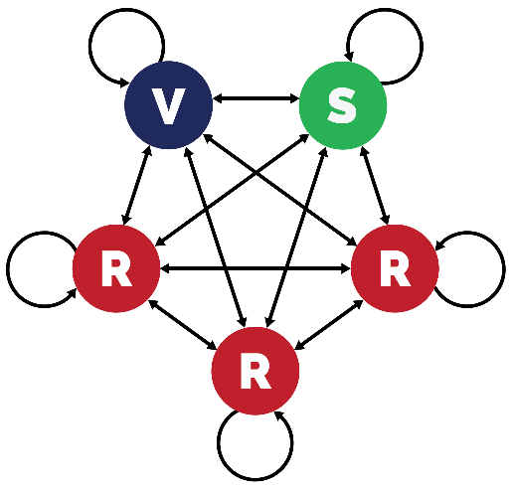

Figure 1. Contact structure for the 20-20-60 model. There are 5 segments, each comprising 20% of the total. V = vulnerable; S = shielders; G = general population. Transmission occurs within and between segments. Transmission rates within and between the three G segments are always homogenous, but may vary within and between segments of different types.

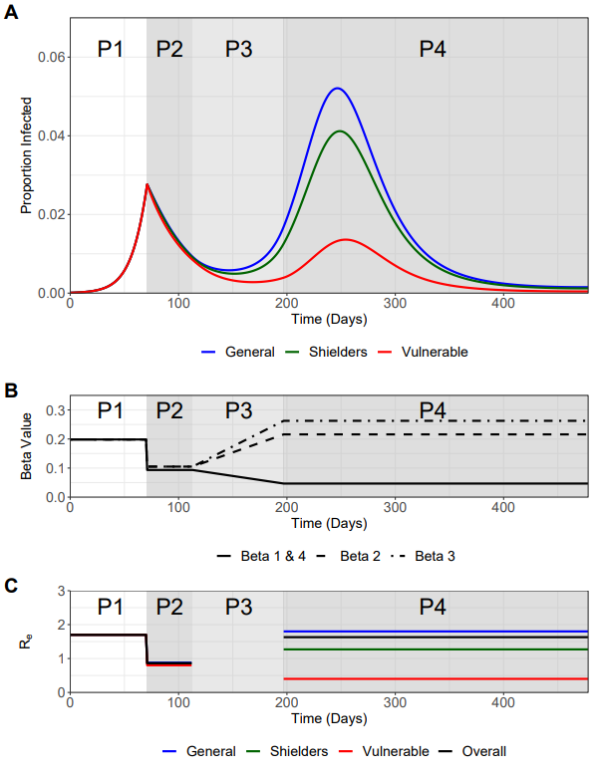

**Figure 2 – Trajectory plots for the vulnerable, shielders and remainder populations, with accompanying β and Re plots**. P1-4

A) Trajectory plots of the proportion of those infected in the vulnerable (green), shielders (red) and general subpopulations (blue), shading depicts the different phases of enhanced shielding intervention.

B) Values for the different β over the course of the simulation as they are implemented for the different intervention phases.

C) Values of the corresponding Re’s (colours) for the different subpopulations and the overall Re (black) during the different intervention phases.

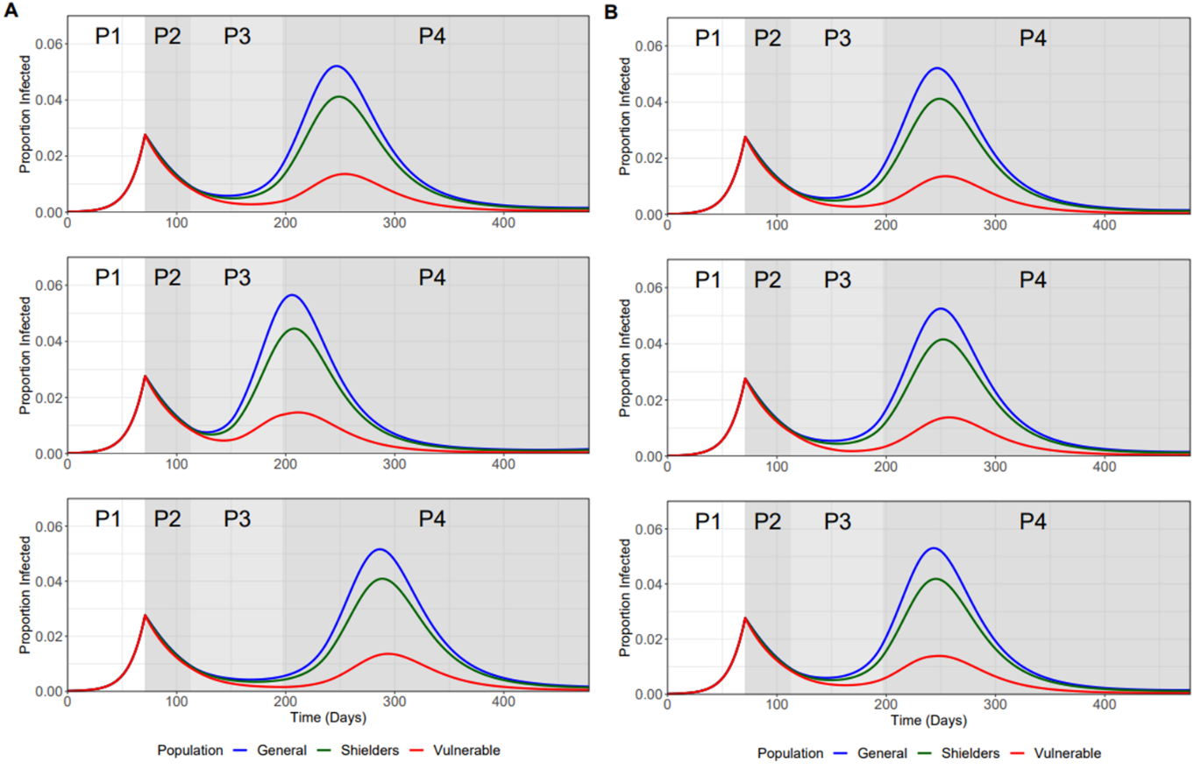

**Figure 3 – Sensitivity analysis for the length of phase 3 ramp-down (β1 & β4) and ramp-up (β2 & β3) periods.** Top plot for both A) and B) refers to baseline values.

A) TOP plot: 12 Weeks ramp-up (β3 & β4) and 12 Weeks ramp-down (β1 & β4), MIDDLE plot: 6 Weeks ramp-up and 12 Weeks ramp-down, BOTTOM plot: 18 Weeks ramp-up and 12 Weeks ramp-down.

B) TOP plot: 12 Weeks ramp-up (β3 & β4) and 12 Weeks ramp-down (β1 & β4), MIDDLE plot: 12 Weeks ramp-up and 6 Weeks ramp-down, BOTTOM plot: 12 Weeks ramp-up and 18 Weeks ramp-down.

C-F??? Need clearer legend

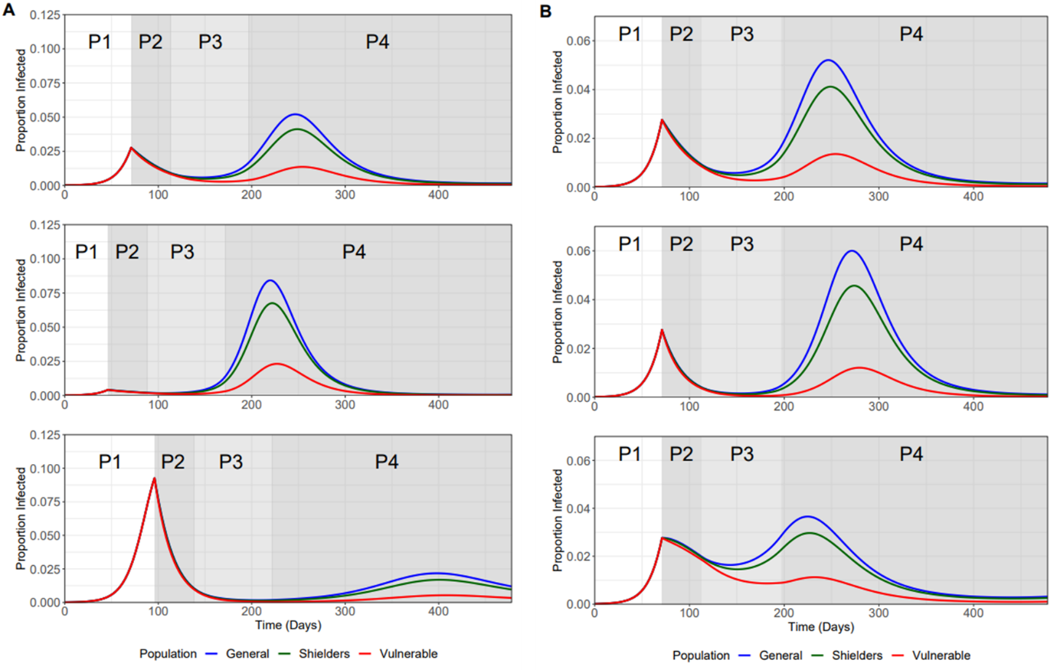

**Figure 4 - Sensitivity Analysis for varying the trigger Point and phase 2 β.** Top plot for both A) and B) refers to baseline values.

A) Trajectory plots for the subpopulations for varying trigger points (starting day of lock down; I(t) refers to the fraction of vulnerable infected on trigger day): TOP plot: day 71 (I(t) = 0.0277), MIDDLE plot: day 46 (I(t) = 0.0042), and BOTTOM plot: day 96 (I(t) = 0.0.093).

B) Trajectory plots for the subpopulations for variation in phase 2 β values – variation is referred to in terms of the Re values used to calculate β1 & β4 (first number) and β2 & β3 (second number) phase 2 values: TOP Plot: 0.8/0.9, MIDDLE Plot: 0.6/0.7, and BOTTOM Plot: 1.0/1.1.

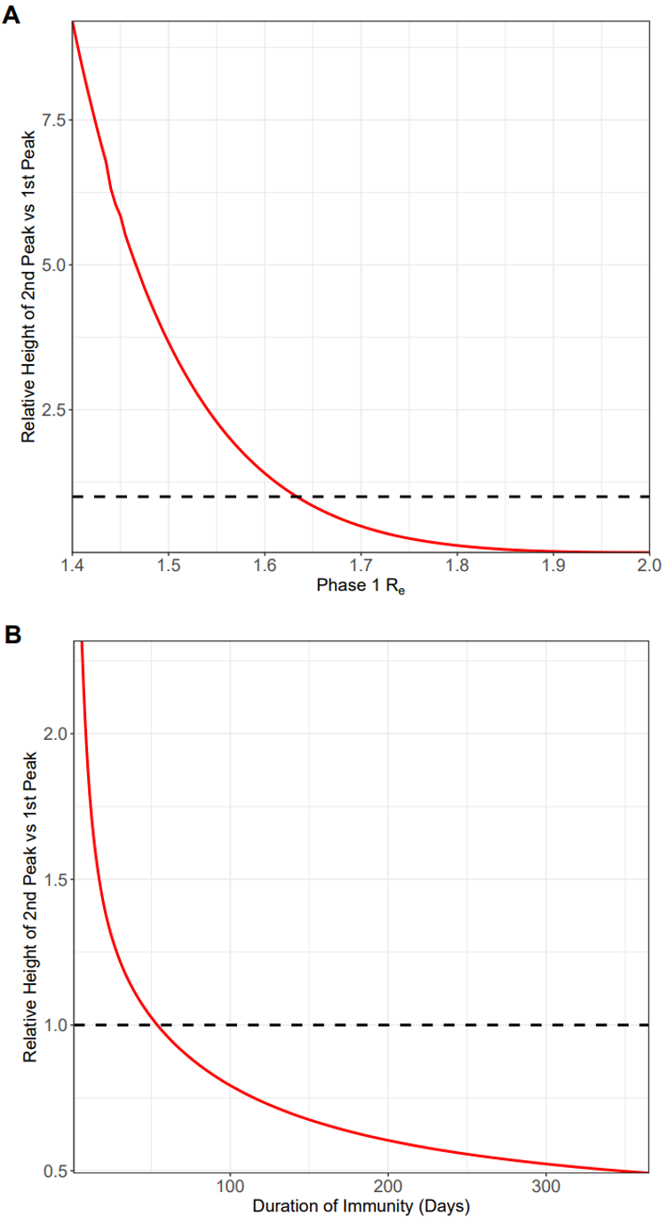

**Figure 5 – Relationship between Phase 1 Beta and Zeta values (expressed in 1/zeta) on the relative height of 2nd peak vs 1st peak for the vulnerable population.** Dotted line represents the point at which the first IV peak equals the second IV peak.

**A)** Phase1 Re is varied between 1.4 – 2.0 (with baseline being 1.7). Re values are used to calculate the β in each model run.

B) The duration of immunity (1/ζ) is varied between 0 and 365 days (baseline).

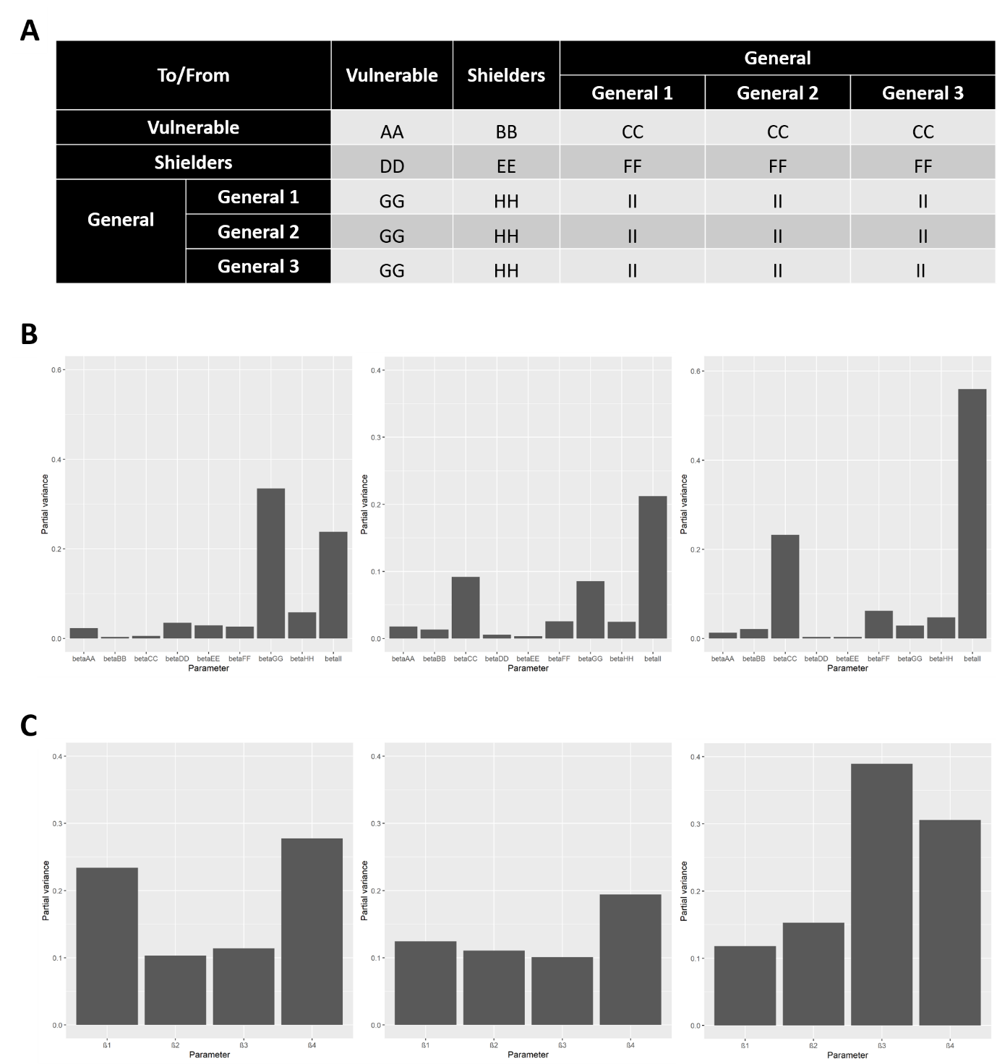

**Figure 6. Results of a global sensitivity (FAST) analysis on three key outcome measures with regards the proportion of the vulnerable population that become infected (Iv)**: 1) the height of the second peak of Iv; 2) whether the second peak of Iv is higher than the first peak and 3) cumulative Iv one year after the start of the lockdown. The bars show the partial variance of the individual model parameters. Higher bars indicate greater sensitivity of the model to that parameter. See Supplementary Methods for details of the sensitivity analysis and parameter ranges used.

A) Description of explored β value “blocks” for the sensitivity analysis. β1, β2, β3 and β4were broken down further to more rigorously assess the sensitivity of the system to these values. Lettering denotes the explored β in the FAST analysis.

B) Sensitivity of the model outcome measures to the β’s specified in A).

C) Sensitivity of the model outcome measures to β1, β2, β3 and β4.

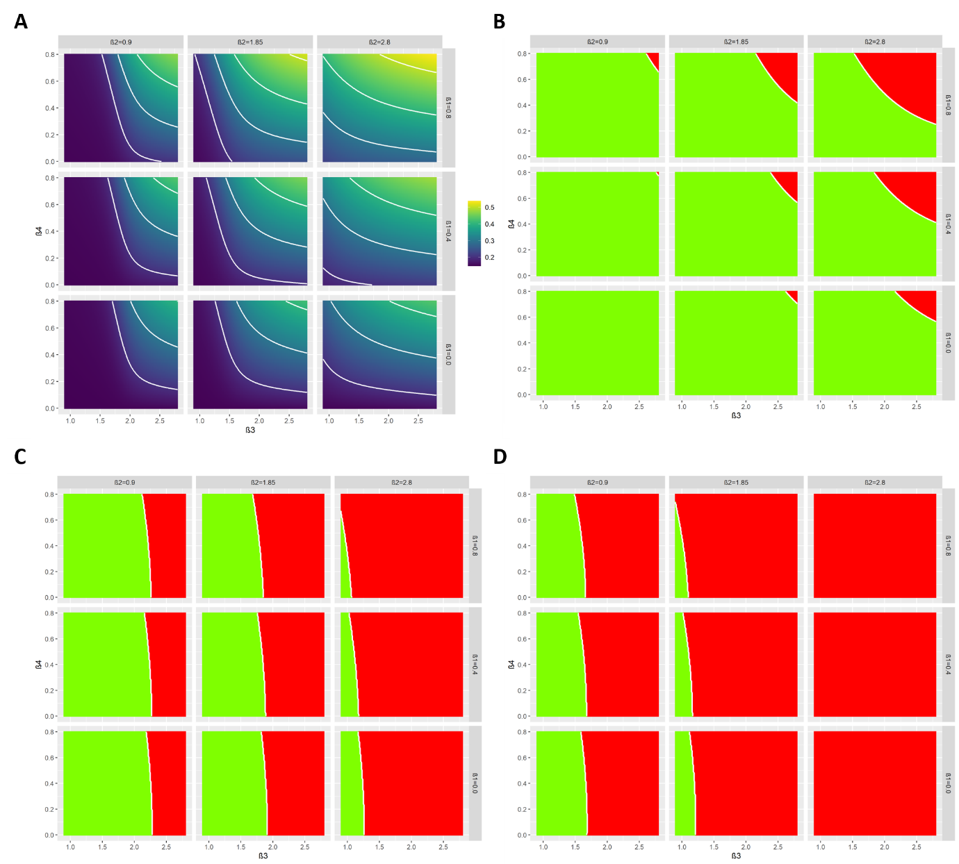

**Figure 7. Heat maps showing the trade-off between relaxation (left to right on horizontal axis) and increasing protection (top to bottom on vertical axis)**.

A) Heat maps describing the cumulative infected vulnerable fraction (Iv) one year after the start of lockdown for different combinations of β3 and β4 for different values of β1 (rows) and β2 (columns).

B) As A) but for whether the second peak of Iv is lower (green) or higher (red) than the first peak.

C) As (B) but all 2nd peaks (Iv, Ih, Ig) smaller than 1st peaks (green).

D) As (B) but dI­/dt is negative or zero for at least 1 year after the start of lockdown for all I-compartments.

Tables

Table 1. Comparison of the estimated distribution of COVID-19 burden for the 20-20-60 and the 2-2-96 scenarios

|  |  |  |  |  |  |
| --- | --- | --- | --- | --- | --- |
|  | Sub-population | Proportion of population | Relative risk of severe disease | Cumulative incidence* | Proportion of severe disease burden* |
| 20-20-60  model | V | 0.20 | 16 | 0.316 | 0.63 |
| s + g | 0.80 | 1 | 0.730 | 0.37 |
| 2-2-96  model | V | 0.02 | 64 | 0.163 | 0.37 |
| s + g | 0.98 | 1 | 0.944 | 0.63 |

*Over one year from start of lockdown (day 71)

**SUPPLEMENTARY INFORMATION**

**METHODS SUPPLEMENT**

**Description of Model Structure**

A frequency-dependent SIRS-type model was used to explore the effect of enhanced shielding with three sub-populations being modelled:

* Vulnerable Population (NV) - Those who have risk factors that place them at elevated risk of developing severe disease if infected with COVID-19 and so would remain shielded whilst the rest of the population is gradually released from lockdown.
* Shielders Population (NS) - Those who have contact with the vulnerable population and include carers, certain care workers and healthcare workers. It is expected that they would also continue some shielding whilst the rest of the population is released from lockdown.
* General Population (NG) - The majority of the population – those that are not vulnerable or shielders.

For the baseline scenario, a population structure of 20% vulnerable, 20% shielders and 60% general was used **(Table M1)**. A total infectious fraction of 0.0001 (split equally across the population) was used as the initial conditions to seed infection. Model parameters were chosen to best describe the transmission dynamics of COVID-19 in the UK using current assumptions (as of publication) regarding the values of key epidemiological parameters **(Table M2)**.

The SIRS model assumes that the number of new infections in a sub-population is a function of the fraction of the sub-population that is susceptible (SX), the fraction of the sub-population that is infectious (IX) and the rate of infectious transmission between the two sub-populations (βX). Infectious individuals subsequently recover at a rate γ that equates to an infectious period of 8.56 days. Recovered individuals are assumed to lose immunity and return to being susceptible over 365 days (**Eqn 1.1**). All β were calculated as a function of the reproduction number and gamma (γ) (**eqn 1.2**). Gamma itself is calculated as the reciprocal of the generation time, which is a function of the baseline basic reproduction number (R0) and the baseline doubling time (T2) (**eqn 1.3**)

**Table M1** – SIRS Model Compartments and Initial Conditions for Baseline Scenario

|  |  |  |
| --- | --- | --- |
| Compartment | Description | Initial Conditions |
| SV | Susceptible fraction of the vulnerable population | 0.19998 |
| SS | Susceptible fraction of the shielder population | 0.19998 |
| SR | Susceptible fraction of the general population | 0.19994 |
| IV | Infectious fraction of the vulnerable population | 0.00002 |
| IS | Infectious fraction of the shielder population | 0.00002 |
| IR | Infectious fraction of the general population | 0.00006 |
| RV | Recovered fraction of the vulnerable population | 0 |
| RS | Recovered fraction of the shielder population | 0 |
| RR | Recovered fraction of the general population | 0 |

**Table M2** – Parameter Descriptions and Values

|  |  |  |
| --- | --- | --- |
| Parameters | Description | Value |
| R0 | Baseline basic reproduction number | 2.8 |
| T2 | Baseline doubling time | 3.3 days |
| βx | Per capita rate of infectious transmission | Varies (see Table 3) |
| γ | Per capita rate of recovery | 0.1167 day-1 |
| ζ | Per capita rate of immunity loss | 0.0027 day-1 |

Eqn1.1

Eqn1.2

Eqn1.3

**WAIFW Matrix and Modelling Transmission**

A “who acquires infection from whom” (WAIFW) matrix was created to describe transmission between the three sub-populations (**Tabl**e **M3**). For the baseline scenario of 20-20-60, the general population was split into three subgroups, to explicitly model differences in contact/transmission between the general sub-population and the vulnerable/shielders.

Segregating of the general population into sub-groups allowed for greater flexibility in the frequency-dependent framework, enabling variation to be modelled in the transmission rates between different sub-populations, whilst, critically, maintaining a globally balanced and fixed R0/Re value throughout the model. However, the three general population sub-groups are functionally identical, with homogenous mixing in the general sub-population assumed to occur and with β values being identical within/between the general sub-groups.

Four β values were used to parameterise the model: β1 describes transmission within/between the vulnerable and shielder subpopulations, β2 describes transmission between shielders and the general subpopulations, β3 describes transmission within the general subpopulations and β4 transmission between general and vulnerable subpopulations (Table M3).

**Table M3** – Generic WAIFW matrix used for the model and the transmission parameters β, which defines transmission between subpopulations

|  |  |  |  |  |  |  |
| --- | --- | --- | --- | --- | --- | --- |
| To/From | | Vulnerable | Shielders | General | | |
| **General 1** | **General 2** | **General 3** |
| Vulnerable | | β1 | β1 | β4 | β4 | β4 |
| Shielders | | β1 | β1 | β2 | β2 | β2 |
| General | **General 1** | β4 | β2 | β3 | β3 | β3 |
| **General 2** | β4 | β2 | β3 | β3 | β3 |
| **General 3** | β4 | β2 | β3 | β3 | β3 |

The WAIFW matrix structure allows for similar levels of transmission within the vulnerable and between the protective shielders sub-population (β1). Shielders themselves can subsequently contact the general sub-population at a different level (β2), with the general population having greater levels of contact with one other (β3). Transmission between the vulnerable and general sub-populations was assumed to be much lower than with other sub-populations (β4).

**Modelling Enhanced Shielding**

To model the effect of an enhanced shielding strategy on COVID-19 transmission, four intervention “phases” were considered. These phases describe social distancing measures which aim to control a COVID-19 epidemic. Interventions were modelled as alterations in the effective reproduction number (Re) values (translated into β values) (eqn 1.2), representing changes in infectious pressure resulting from these control measures.

In the context of an enhanced shielding strategy, the intervention phases were assumed to impact the Re values (and subsequently the β values) differently within/between each sub-population, to reflect the loosening or tightening of social distancing measures throughout the progression of the outbreak (**Table M4**). The transition from phase 1 to phase 2 represents the hard lockdown implemented on the 24th March 2020, phase 3 represents a progressive release (for the general subpopulation) or tightening (for the vulnerable subpopulation) of restrictions applied over a 12-week period. Phase 4 represents the end point of the gradual transition of phase 3. The model simulations start on day 0 and lockdown is implemented on a selected “trigger day" which corresponds to where the proportion of total recovered individuals (Rtot) is 0.06 seven days after the trigger day. The Re values that are modelled in the baseline scenario are also shown in **Table M4** and were used to calculate the β values used in each phase and the resulting β values are shown in **Table M5**.

**Table M4** – Description of Phased Enhanced Shielding Strategy

|  |  |  |  |  |  |  |
| --- | --- | --- | --- | --- | --- | --- |
| Phases | Description of Intervention Phase | Duration | Re used to calculate β* | | | |
| **β1** | **β2** | **β3** | **β4** |
| Phase 1 | Represents the “business as usual” approach that was operating pre-lockdown. We assume a pre-lockdown Re of 1.7 – reflecting pre-existing reductions to transmission from a baseline R0 = 2.8 (spontaneous social distancing etc). | Up until Rtot(tp+7) = 0.06  (tp=day 71) | 1.7 | 1.7 | 1.7 | 1.7 |
| Phase 2 | Represents the nationwide lockdown that was applied approximately equally to all subpopulations. We assume that pre-existing shielding in the vulnerables has resulted in reductions to Re relative to the shielders and general subpopulations (Re = 0.8/0.9). | 6 Weeks | 0.8 | 0.9 | 0.9 | 0.8 |
| Phase 3 | Represents a progressive change in restrictions – a progressive release of regulations to the general subpopulation and a progressive tightening of restrictions applied to the vulnerable subpopulation. R­e values change linearly from phase 2 to phase 4 over the course of 12 weeks. | 12 Weeks | Linear Change to Phase 4 | | | |
| Phase 4 | Represents the long-term application of the released restrictions to the general subpopulation and long-term enhanced shielding of vulnerable subpopulations. We assume that Re is reduced further in the vulnerables by ½ as part of the enhanced shielding strategy. Based on a “back-to-normal” R0 = 2.8, we model a partial return back-to-normal for the shielders (even greater return for the remainder). We assume a central value between lockdown and back to normal for the shielders (0.9 < R < 2.8), and a central value between pre-lockdown and back-to-normal for the general sub-population (1.7 < R < 2.8). | Until End of simulation  (1 Year after lockdown ends – 478 days from start of simulation) | 0.4 | 1.85 | 2.25 | 0.4 |

* All Re values used are for illustrative purposes and are best guess for the effect of interventions and SDMs based on expert opinion. tp=trigger point (daynumber) for start of lockdown.

**Table M5**. β values used for baseline scenario.

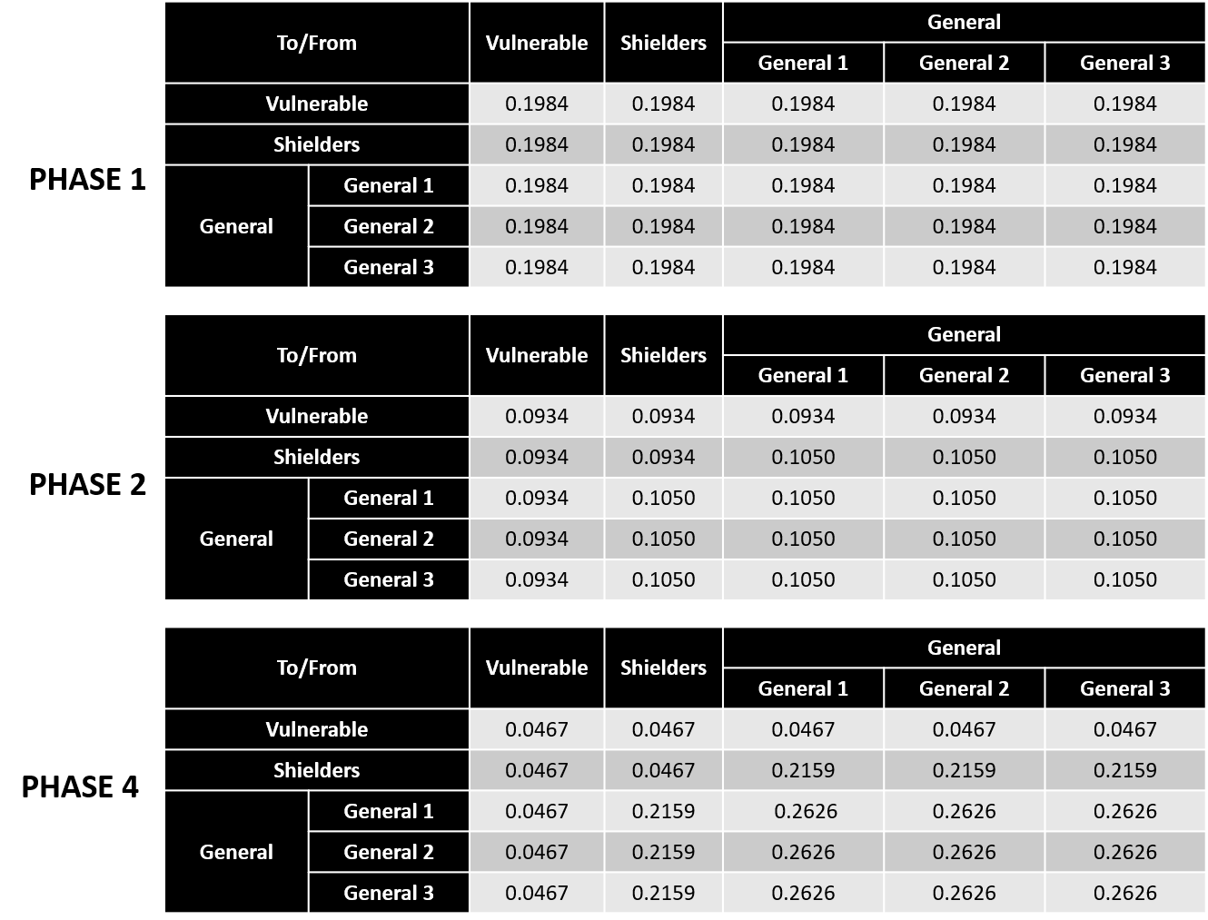

**Sensitivity Analysis**

To test the susceptibility of the core results to key parameters and uncertainty in the model formulation, several sensitivity analyses were conducted. These explored:

1. Varying P1 Re values from the baseline value of 1.7 (explored range of 1.4 – 2.0)
2. Varying P2 Re values from the baseline value of 0.8/0.9 (explored range of 0.6/0.7 – 1.0/1.1)
3. Varying the trigger day from day 71 to day 46 and 96.
4. Varying the duration of the P3 ramp-down (β1 & β3) and ramp-up (β1 & β3) from baseline of 12 weeks (explored range of 6 – 18 weeks)
5. Assessing the sensitivity of the main model output to individual beta values in the WAIFW matrix

**Description of FAST Analysis**

We determine which model parameters have most influence on the outcome values (height of second peak fraction of the vulnerable population that are infectious (Iv) , whether the second peak of Iv is higher than the first peak and the cumulative fraction of Iv one year after the start of lockdown) by computing the total sensitivity index *D*Ti using the extension of Fourier amplitude sensitivity test (FAST) as described in Saltelli *et al.* [ref Saltelli].

The extended FAST method is a variance-based, global sensitivity analysis technique that has been largely used for studying complex agricultural, ecological and chemical systems (see [ref Makowski, ref Neumann] for examples). Independently of any assumption about the model structure (such as linearity, monotonicity and additivity of the relationship between input factors and model output), the extended FAST method quantifies the sensitivity of the model output with respect to variations in each input parameter by means of spectral analysis.

It provides measures of the amount of variance of the prevalence that arise from variations of a given parameter in what is called a total sensitivity index, *D*Ti. It therefore captures the overall effect of parameter variations on the chosen outcome values (i.e. including first- and higher-order interactions between model parameters). For example, a value of *D*Ti = 0.10 indicates that 10% of the total observed variation of the prevalence is explained by the parameter under consideration. The sensitivity analysis was carried out using R [ref R (version 3.6.3)]. For the sensitivity analysis, we used a parameter range of -25% to +25% of the baseline value for all parameters under investigation.

**Disease burden**

… (Figure SX).

**Software used**

SIRS model implemented in R and C++ independently (code available at <https://github.com/bvbunnik/COVID-19-enhanced-shielding.git>). Package “desolve” was used in R to implement model structure and analysis. Package “ggplot2” was used for all output plotting.

**References**

* Saltelli A, Tarantola S, Chan KPS. 1999A quantitative model-independent method for global sensitivity analysis of model output. Technometrics 41, 39–56. (doi:10.2307/1270993)
* Makowski D, Naud C, Jeuffroy M-H, Barbottin A, Monod H. 2006Global sensitivity analysis for calculating the contribution of genetic parameters to the variance of crop model prediction. Reliability Eng. Syst. Safety 91, 1142–1147. (doi:10.1016/j.ress.2005.11.015)
* Neumann MB, Gujer W, von Gunten U. 2009Global sensitivity analysis for model-based prediction of oxidative micropollutant transformation during drinking water treatment. Water Res. 43, 997–1004. (doi:10.1016/j.watres.2008.11.049)
* R Core Team (2020). R: A language and environment for statistical computing. R Foundation for Statistical Computing, Vienna, Austria. URL:https://www.R-project.org/.

SUPPLEMENTARY FIGURES

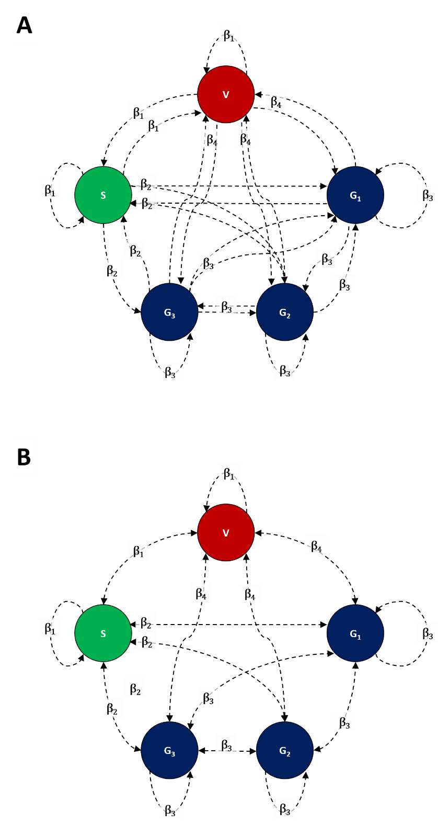

**Figure S1** - The SIRS model structure (A) defined by Susceptible, Infectious and General compartments and (B) the 20-20-20-20-20 network structure with five equal sized populations: vulnerable (V), shielders (S) and three general populations (G1, G2 and G3). This illustrates the baseline with five equal sized populations, but can be extended to n equal sized populations by increasing the number of general subpopulations. We define four values of the rate of transmission (β) with β1 defining the rate of transmission within and between the vulnerable and shielders; β2 defines transmission between shielders and general subpopulations; β3 defines transmission between the general populations and β4 defines transmission between general and vulnerable populations. People in the Infectious compartments recover at rate γ and people in the recovered compartments lose immunity at rate ζ.

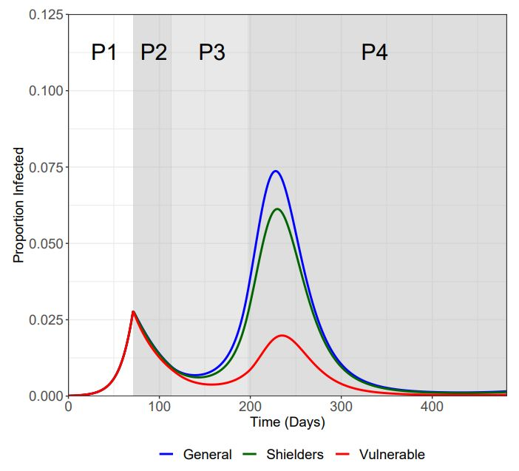

Figure S2. As Figure 2A for the 2-2-96 model.

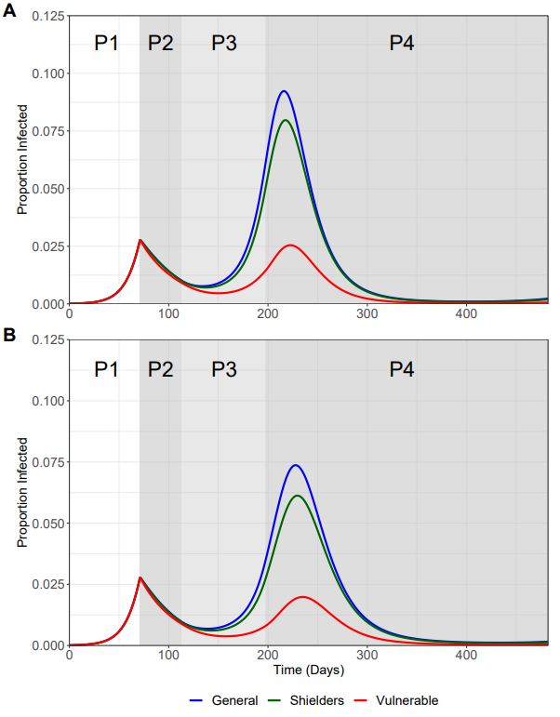

Figure S3. As figure 2A, but A) for 8-8-84 model structure and B) for 14-14-72 model structure.

SUPPLEMENTARY TABLES

Table S1. COVID-19 Shielding in the UK. A) Definition of vulnerable population [NHS Digital, 2020; Scottish Government, 2020]. B) Shielding advice [Public Health England, 2020].

**A**

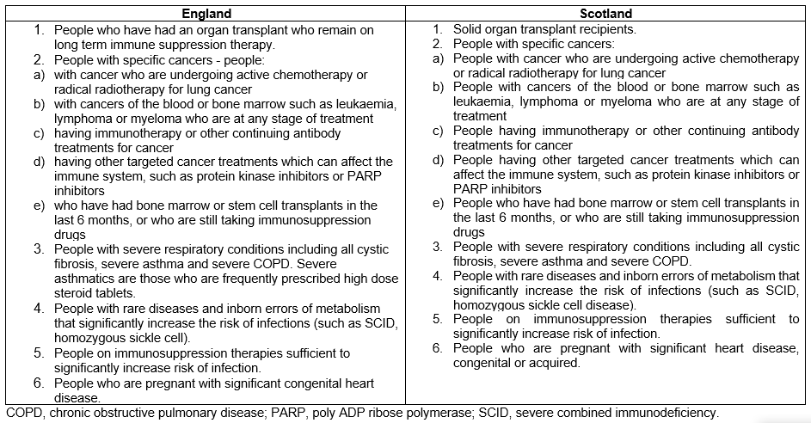

**B**

